Curbing and Bettering Puppy Mills
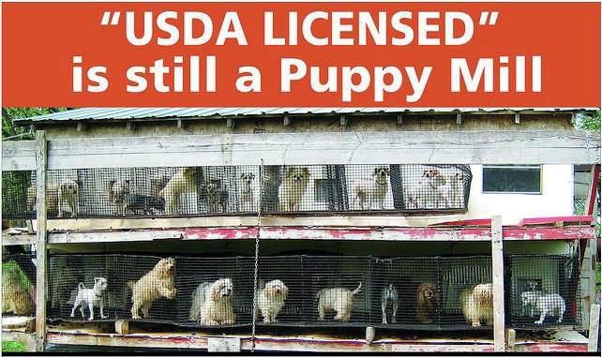
The whimsical puppies one may see at the windowsill of a puppy store may be completely unaware of where exactly these puppies originated. The sticker on the small, compact window of where these puppies prance around may read something like, “USDA Licensed Breeder from East Earl, PA”. Little do these potential four legged owners know that this licensed breeder is more than likely running a massive puppy mill. Until this day, there is not a standard and official definition of a puppy mill, but in general, a puppy mill is an establishment that breeds puppies for sale typically in inhumane and unethical ways. These U.S. Department of Agriculture (USDA) licensed puppy mills are required to abide by the Animal Welfare Act (AWA) that ensures the humane treatment of these animals. Although the USDA puts the AWA in place in order to regulate these puppy mills, the inspections performed by the programs under the USDA have proven to be weak and ineffective—allowing these large-scale breeders of these puppy mills to easily swivel through the loopholes of the AWA. The problem behind these puppy mills ultimately underlies within the Animal Welfare Act-- as it is far too broad and ineffective at specifically targeting these nationwide puppy mills. In order to effectively combat these puppy mills, I advocate for the states to enact laws that regulate these puppy mills, rather than the federal government, in addition to local ordinances that ban the sale of puppies from puppy mills that have violated any state and federal laws.
An example of a typical USDA Licensed puppy mill.
Currently, the USDA inadequately “enforces” the Animal Welfare Act and has made it nearly ineffective upon the puppy mills. The USDA allows the existence of puppy mills as long as these licensed facilities abide to the Animal Welfare Act (AWA) which is the only federal law in the United States “that regulates the treatment of animals in research, exhibition, transport, and by dealers” (“Animal Welfare Act”). The USDA ensures that these puppy mill business owners are abiding by the AWA by inspecting these facilities at least once a year through the Animal Care Unit (AC), a program under the USDA that is responsible for animal inspections. The problem exists within the AC’s inspections of these puppy mills. Many of these violators who operate these inhumane puppy mills are not cited for their violations but are simply just “slapped on the wrist” with insignificant warnings and no misdemeanors. Katherine C. Tushaus, a JD graduate from the Drake University Law School, agrees with the inconsistent enforcement mechanisms behind the AWA in the Drake Journal of Agricultural Law, as she stated, “…penalties were often so low that violators regarded them as a cost of doing business and… the agency accommodated facilities that repeatedly refused access to inspectors rather than suspending their licenses” (Tushaus). Many of these severe violations account for a variety of different abuses such as the health of the dogs and the environment these dogs live that is often contaminated with feces, viruses, and insects as pictured in Figure 2 and Figure 3.
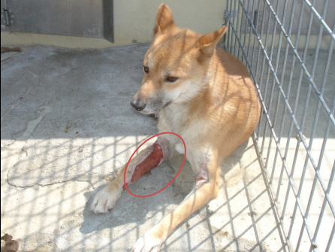
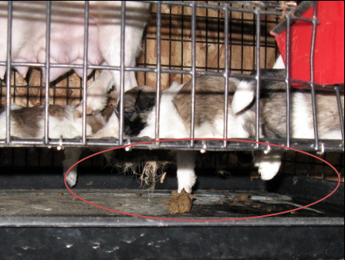
Figure 2: Missouri breeder violated AWA: This dog had an injured leg, raw flesh and
bones exposed. Credit: USDA
Figure 3: Ohio breeder violated AWA: This was an unsuitable kennel for puppies because
their paws slipped through the wires, allowing regular contact with feces. Credit: USDA
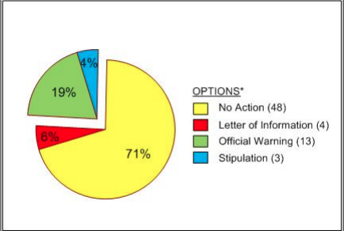
In addition, when the USDA audited the AC in 2010, the audit gave proof to numerous violations that were not taken seriously. In most cases, many of these gruesome violations were cited as an indirect or a minimal violation that entailed no follow-ups (U.S. Department of Agriculture). As seen in Figure 4, 71% of these AC inspectors took no action against the violations and loathed away from the other appropriate options that would require follow-ups. Although there is no certainty as to why such decisions were made, may it be due to negligence or inadequate funding, it is certain that the AWA lacks enforcement. Katherine Tushaus, who was mentioned earlier, agrees with this notion as she explained that “the agency lacks a sufficient number of personnel to inspect the thousands of facilities scattered across the country that are covered by the Animal Welfare Act [because the] Animal Welfare Act encompasses a large range of facilities that deal with and house animals, most of which do not participate in commercial breeding practices” (Tushaus). The federal government fails to properly enforce the AWA because the AWA is too broad and weak to combat the numerous puppy mills that exist all through out our nation.
Figure 4: USDA Audit: The options the inspectors chose upon violators. Credit: USDA
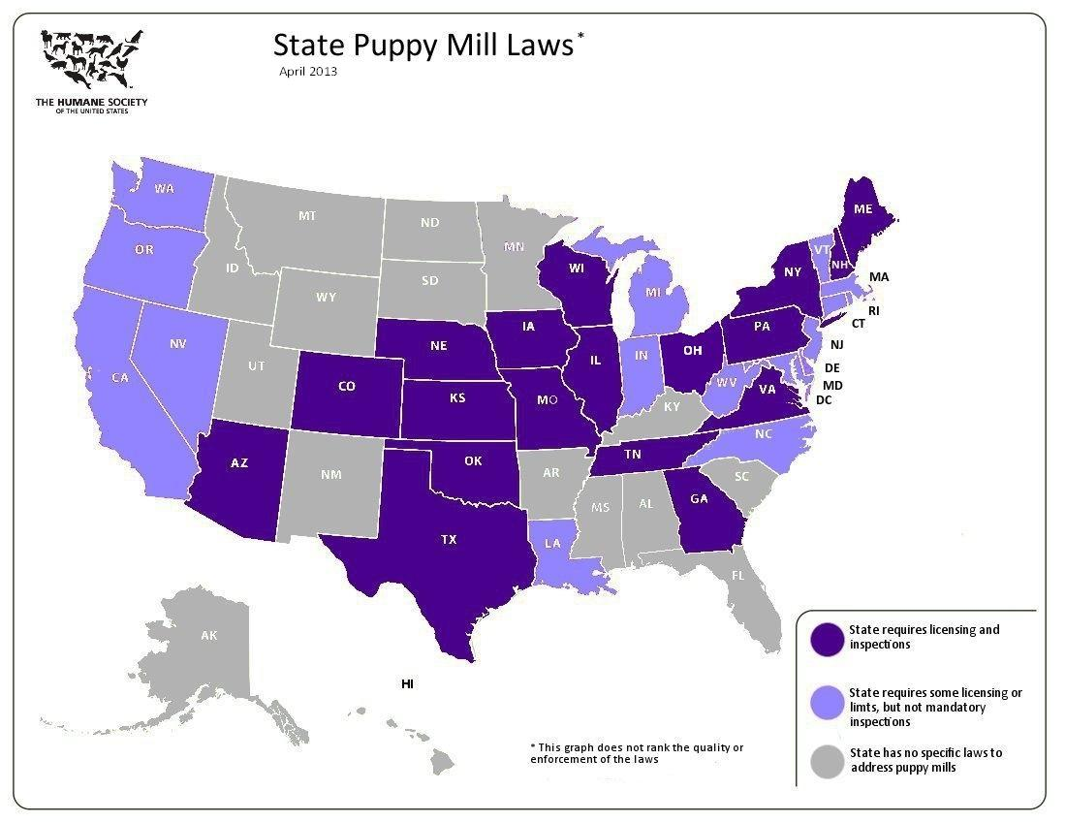
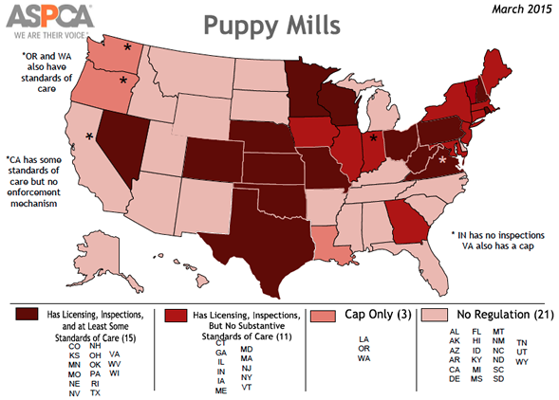
Due to the lack of enforcement from the federal government, states and local ordinances should combat these puppy mills because they have greater powers that can specifically target the issues behind puppy mills. Through the U.S. Constitution and Federalism, states have more power to enact higher standards amongst these puppy mills than the minimal requirements of the federal government. Currently, by the federal standards, there are only about 100 inspectors that are responsible to do more than 15,000 inspections per year – a clear indication that there are not enough inspectors and inspections (Madrigal). By giving the power and responsibility to the states to regulate and inspect these puppy mills, the states are enabled to control these puppy mills in a more intimate way because many of these inspectors would not be responsible for such a mass amount. Sandra Jones, a J.D. graduate from Rutgers University, mentioned in Rutgers Journal of Law & Public Policy that there is a clear, inadequate enforcement of the AWA and further propagates her argument by asserting the need for states to get involved. Jones mentioned that these state laws “…have made major efforts to improve the animal cruelty laws in their jurisdictions” and supports the idea of giving the states the power to regulate these puppy mills because these new laws “provide clear authority” (Jones). Over half the states have adopted this mentality, as 29 states have currently enacted some sort of puppy mill law. Many of these puppy mill laws are not uniform however, as some laws are more rigid and strict than others. Robyn F. Katz, an attorney for an animal welfare nonprofit in Washington, points out in Michigan State University’s Journal of College of Law the state laws variability, as he mentioned, “States laws vary, but most states that do have laws address sanitation, housing, food and water requirements, the governing agency, and inspections; few address veterinary care and the humane treatment of dogs, ventilation, and exercise” (Katz). This is indeed true, evidently shown in maps below; each state has different laws that have varying standards and degrees of regulation – some states do not have any laws, some states have laws without inspection while some do, etc. Despite this variability, one particular state stands out amongst the other states that regulate puppy mills that may serve as a “template” for other states – Pennsylvania.
Map of the states & Puppy Mill Laws. Dark Purple: Require inspection. Purple: No mandatory inspections. Gray: No law
Courtesy of HSUS
Map of the states & Puppy Mill Laws. Dark Red: Regulations & Standards of Care. Solid Red: Regulation only. Dark pink: Cap Only. Light Pink: No law.
Courtesy of ASPCA
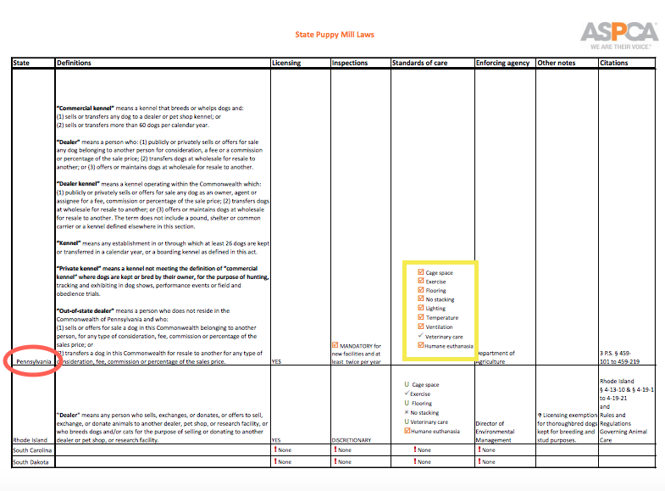
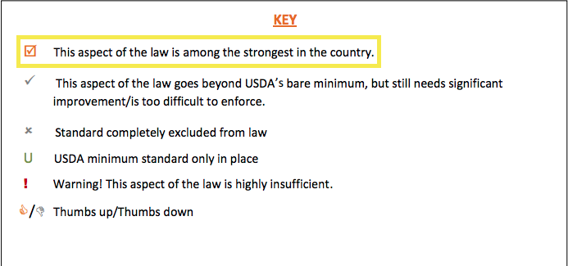
Pennsylvania, infamously known as one of the many states in the Midwest that runs puppy mills, arguably has the strictest puppy mill laws in the United States as of today. Despite its infamous title and reputation, Pennsylvania has been improving the issues behind puppy mills more so than the other popular Midwest states that are known to operate puppy mills (Staff, Associated Press). Under the Pennsylvania Dog Law, the puppy mill breeders are required to abide by these law provisions, which include but are not limited to: double cage sizes, eliminated wire flooring, provided unfettered access to the outdoors, banned cage stacking, instituted twice-a-year vet checks, and mandated new ventilation and cleanliness standards (“New Pa. Law Putting Puppy Mills out of Business”). In addition to these provisions, Rebecca F. Wisch, a J.D. graduate from Michigan State University, mentioned in Michigan State University’s Journal of College of Law that the state’s Bureau of Dog Enforcement “…mandates inspection of all licensed kennels at least twice a month” (Wisch). As shown in Table 5 below, Pennsylvania evidently holds the longest list of requirements behind their law.
Table 5: A snippet of all the states’ puppy mill laws. Pennsylvania had the most requirements under their state law. Credit: ASPCA
Should any of these provisions be violated, the owner may face misdemeanor charges that cost up to $2000 plus court costs. This stringency and specificity behind this law has proven to be so successful that many Pennsylvania puppy mills have voluntarily shut down – reducing, “303 [puppy mills] to 111 [puppy mills] - a reduction of almost two-thirds” (“Staff, Associated Press”). Thus, the Pennsylvania Dog Law serves as a paramount example of how impactful and influential a state law can be in fighting these inhumane puppy mills. Whether or not the other states currently have laws concerning puppy mills, these states should take advantage of their power and use the Pennsylvania Dog Law as a template to enact their own puppy mill laws to enforce higher standards than the bare minimums of the federal government. In addition, Melissa Towsey, a graduate law student from the University of Villanova, credited Pennsylvania’s Dog Law as a “…pioneering legislation for the humane treatment of kennel dogs” in the Villanova Environmental Law Journal (Towsey). Indeed, the Pennsylvania Dog Law can truly serve as a catalyst and initiator to other states to enact similar laws that may be even better than Pennsylvania’s law itself. In addition to this law, all state inspectors should be highly trained and held accountable for their inspections by setting a reported “quota” or a “target goal” of reported violations to ensure that the inspectors are doing their job. In other words, states should independently formulate a minimum and appropriate amount of violations that need to be reported by the inspectors. By setting an “X” amount of violations that need to be reported, inspectors would not take the chance of simply “slapping the wrists” of the violators because they would be held accountable to report a certain amount. With these strict laws that have numerous requirements inspired by the Pennsylvania Dog Law, along with the accountability of the inspectors, states’ bureau inspectors would be able to regulate and inspect with more adequacy and stringency of these inhumane puppy mills more so than the federal government’s AC inspectors, in addition to possibly shutting down puppy mills that can not accommodate to the necessary requirements.
The states enacting puppy mill laws definitely address the inspection issue, but adding in local ordinances can further limit and possibly impede the profiting businesses of these puppy mills. Local ordinances conducted by the cities are vital to fighting puppy mills because they play a crucial role in changing the public and governmental perceptions on moral issues. According to Adam Fumarola, an attorney graduate from University at Buffalo Law School, “Pet stores [are] the leading distributor of puppy mill animals” (Fumerola). This claim is generally true as most pet stores purchase their dogs from puppy mills because they are much cheaper and easy to access ("Puppy Mill FAQ"). By doing so, the puppy stores are creating profit for these puppy mill businesses. Therefore, because puppy stores are the main source of profit to many puppy mills, local ordinances should regulate puppy stores to further curb the businesses of puppy mills. These ordinances should prohibit retail stores from purchasing puppies from puppy mills that have numerously violated the Animal Welfare Act and any additional state laws. Krysten Kenny, a JD graduate from Albany Law School, agrees with this proposal in the Albany Law Review, as she argued, “By cutting off the ability of retail pet stores to sell their live products, these ordinances aim to curtail the demand for puppy mill dogs…” (Kenny). This ensures that any puppy mill facility that is inhumane and unethical will eventually run out of business because many puppy stores would reject buying puppies from them. This sort of ordinance has already been enacted successfully in cities like New York City. In January of 2015, New York City’s Mayor, Bill de Blasio passed a groundbreaking ordinance and created a law that “prohibits [retail stores] from buying puppies from commercial puppy brokers or from USDA-licensed breeders with severe Animal Welfare Act violations” (“Law Enacted to Prohibit Sale of Puppy”). Many animal advocates, as seen in the picture below of an advocate supporting Mayor de Blasio, hailed at this new victory of such law. Furthermore, many local ordinances concerning puppy mills and retail pet stores have recently been passing as more of the cities’ public is becoming more aware of where these puppies are originating from. Popular
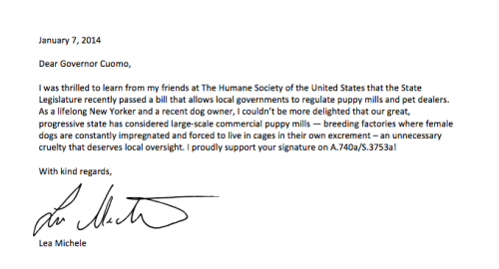
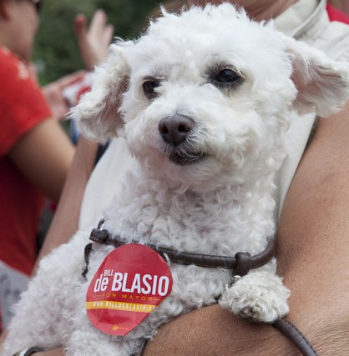
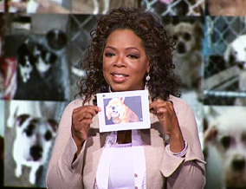
celebrity figures like Oprah Winfrey, pictured above, and Lea Michele have brought immense amount of attention to these unethical puppy mills that have affected both the state and local cities. Lea Michele, for example, prompted New York to pass stricter state laws that regulate puppy mills quite recently. In the letter seen above, Michele was successfully able to gather enough public attention to further enhance the puppy mills laws in the state of New York.
Thank you letter from Lea Michele to Governor Cuomo for passing stricter state puppy mill laws.
Credit: Humane Society
Animal advocate of Mayor Bill de Blasio. Courtesy of Laika Magazine
Oprah discussing the issues behind puppy mills on the Oprah Winfrey Show. Courtesy of the Oprah Winfrey Show.
Sandra Jones mentions that such public educational efforts from Oprah Winfrey, and in general, any influential person, were the “…beginning for anti-puppy mill spokespeople such as ASPCA attorney Cori Menkin, Bill Smith of MLAR, and attorney Buzz Miller, [to begin] speaking at state-wide seminars and alerting the public to problem of puppy mills” (Jones). In effect, many of the locals’ public have become aware of this issue and have passed numerous, successful local ordinances successfully after much recent media coverage. Nearly 80 cities as of today have successfully enacted laws that prohibit the sale of puppies (and possibly any additional animals) that originated from inhumane puppy mills in retail stores, as seen below in Figure 6.
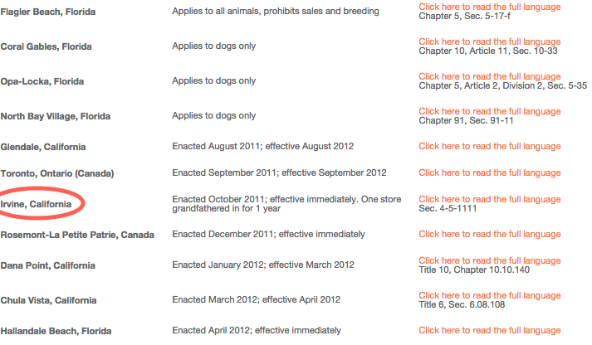
Figure 6: A snippet of all the cities that have prohibited the sale of puppies in retail puppy stores.
Credit: Best Friends Animal Society
In the case of New York City, the city’s Department of Health and Mental Hygiene (DOHMH) enforces this local ordinance (seen in Figure 7) with yearly inspections and regulatory compliance of all New York City pet shops (“NYC”). The DOHMH can revoke, fine, and shut down any noncompliant pet stores (“New York City”). Similarly, big cities have departments that regulate these businesses, while some small cities’ police department regulates these pet stores.
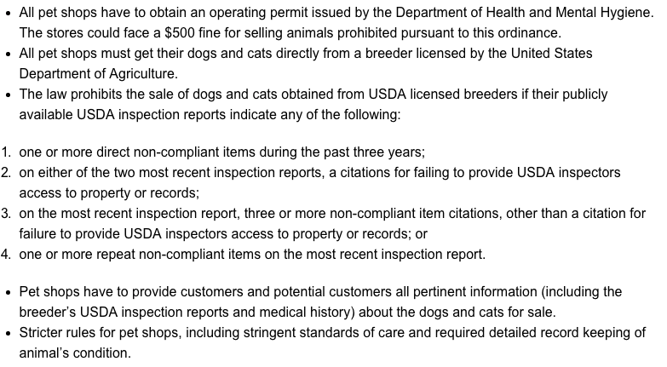
This progression and popularity of local ordinances that serve to end puppy mills gives hope to ending the overall entirety of puppy mills because, as Kenny mentions, “decreasing the supply [of puppies] results in consumers turning to more humane places to get a new companion such as shelters, rescue groups, or small-scale breeders” (Kenny). Not only will the public be making better decisions as to where they should adopt or purchase a puppy, they will also be more informed and educated about the existence of puppy mills. Strict state laws are undeniably necessary to investigate the puppy mills, but in addition to that, communities must pass local ordinances that ensure that these puppy mill businesses do not further succeed and flourish.
Figure 7: New York City’s Local Ordinance enacted in 2014. Credit: Companion Animal Protection Society
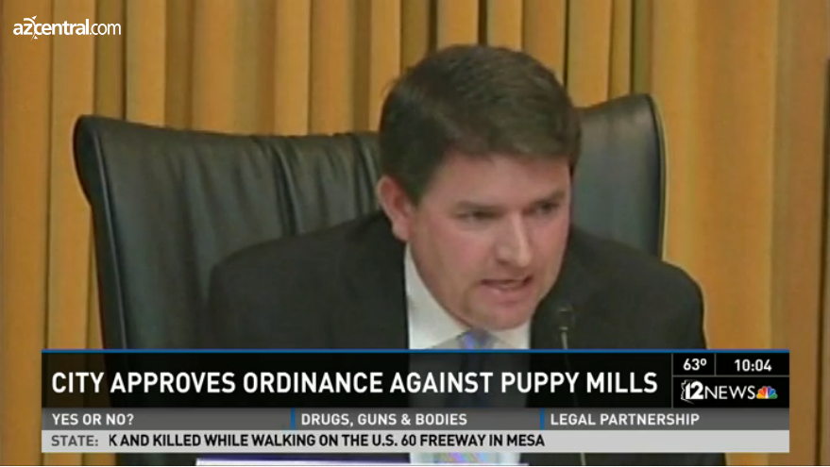
My solutions of having the states pass strict laws inspired by the Pennsylvania Dog Law and having local ordinances that regulates puppy stores may raise some complications and controversy. First and foremost, some would argue to simply ban the existence of puppy mills and to prohibit all sales of puppies, despite their origins, in all pet stores. Although this is completely ideal, as it would completely terminate all puppy mills, it is neither merely logical nor practical due to the Commerce Clause that protects interstate commerce. The Commerce Clause is a constitutional right that “precludes states from enacting laws or regulations that excessively burden interstate commerce” (“Rousso v. State”). Thus, the government cannot simply ban puppy mill businesses, but can only regulate them with the Animal Welfare Act and possibly with existing state laws. In addition, local ordinances cannot simply prohibit all sales of puppies to puppy storeowners, as they would argue that not all puppies come from puppy mills, and thereby, such prohibition would be technically unconstitutional. Certain cities like Phoenix, Arizona have passed local ordinances that have completely ban the sale of puppies in retail stores, but have created a lot of conflict in return. For instance, in a recent court case in July of 2014, Phoenix pet storeowners argued that they did not purchase puppies from inhumane puppy mills, but rather, bought their puppies from regulated, humane breeders, arguing that this ban was completely unfair as it targeted innocent owners (“New PA Law”). In addition to that argument, Tucson Vice Mayor Steve Kozachik, pictured above, stated, “This ordinance says you can’t sell animals that come from a breeder. Period. – Not you can’t sell from inhumane breeders – I would agree with that, but that’s not in here” (“New Paw Law”). Thus, this is why I advocate for a lesser of a radical solution by mandating all states to inspect these puppy mills precisely since they are constitutionally allowed to exist, in addition to the prohibition of the sale of puppies that have come from severely violated puppy mills, rather than a complete prohibition.
Mayor Steve Kozachik arguing against the prohibition of all puppies in pet stores in a court case. Credit: AZ Central
I also acknowledge the fact that if the USDA is unable to regulate the Animal Welfare Act, it may as very well be the same within the states, should they have a puppy mill law. Rebecca Wisch, mentioned earlier, stated, “While new [state] laws certainly reflect a step forward in curbing the problem of puppy mills, critics contend that many of these laws do not go far enough. In fact, one of the main deficiencies in most of the new and existing laws is the lack of adequate inspection systems that ensure compliance” (Wisch). This is definitely plausible, as I do admit that this has already occurred throughout some states, and it is certainly an additional problem to my advocated solution. However, despite this setback, that is precisely why I additionally advocated for accountability to those state inspectors. Currently, no states that have puppy mill laws have some sort of accountability measure upon the inspectors. If this were hypothetically enforced, with the use of violation “quotas”, inspectors would be held more responsible and accountable to report violations and follow-up on those puppy mills; otherwise they would be punished with their own penalties for not conducting an inspection properly. In addition to that, unlike the Animal Care Unit (inspectors from the USDA) that is responsible for the entire nation’s puppy mills, states would inspect a much lesser amount, allowing them to inspect in a magnified way. Thus, it would be the states’ responsibilities to fix that weakness and to not further parallel with the weaknesses of the USDA.
Thirdly, critics may argue for an amendment of the Animal Welfare Act that would make the act much more stronger and effective, rather than mandating the states to enact a puppy mill law. This provision has already occurred, as Katherine C. Tushaus recalls, “In the mid-September 2008, the Puppy Uniform Protection and Safety Act (PUPS) was introduced in both the House and Senate. PUPS aims to amend the Animal Welfare Act to require commercial breeders who produce more than fifty dogs a year and sell directly to the public to be licensed and inspected by the USDA… The PUPS bill is a step towards strengthening the federal regulation of commercial breeders…” (Tushaus). Despite its simplicity, the PUPS Bill showed to be ineffective with its federal regulation and inspections as seen through USDA’s 2010 audit. The practicality of the bill fails to be effective because the USDA is far too broad and large to specifically combat all of the nation’s puppy mills, as they are responsible for almost the entire spectrum of animal treatment. Due to this problem, many loopholes continue to exist despite its numerous amendments. Robert F. Katz agrees with this issue as he mentioned, “…It would be impossible for the USDA to monitor all of the commercial breeding operations. The primary authority to regulate the welfare of animals is through the states, which need to maintain laws that are enforceable and hold people accountable for violating the current laws” (Katz). Thus, if we give this issue to the states, states can work in a specific manner to rightfully regulate and inspect these puppy mills with higher standards since they carry that power. States like Pennsylvania have a Bureau of Dog Law Enforcement that ensures these laws are being enforced while the USDA does not. Surely, should we have effective Bureaus that work together to enforce puppy mill laws in all states, puppy mills can possibly be corrected.
The problems that exist within these puppy mills are undeniably complicated and extremely complex. However, despite this complexity, it is pivotal for the public to become aware of this nationwide issue in order to be able to enact proposed solutions. Thankfully, due to increased amounts of media coverage, the public is slowly, but surely, becoming more aware of the problems that exists in these puppy mills. I advocate for solutions that address the problem in multiple ways – ensuring that the treatment of these dogs are ethical, humane, and more than just minimally acceptable. The states will be able to regulate the inspection in a more intimate and magnified way that ensures that the puppy mill owners are not treating their animals in inhumane ways. By adding accountability to these inspectors, these inspectors would be more motivated to perform their inspections righteously. In the meantime, local cities should fight to end the sale of puppies that originated from violating puppy mills, which would cut out a lot of these puppy mill businesses. If the local ordinances were not passed, at least there could be another potential solution within the states that helps better the treatment of the dogs in the puppy mills. Likewise, if state laws are not passed, at least there could be local ordinances that decrease the supply of puppies from puppy mills. With these solutions and the USDA’s regulations, the loopholes that exist within these puppy mills may cease to exist.

Works Cited
"Animal Welfare Act." Animal Welfare Act. USDA, 26 May 2015. Web. 18 Apr. 2015.
ASPCA. “Puppy Mills Map”. 2015. N.p. Web. 22 May 2015.
This visual map created by the ASPCA was used to show the current puppy mills laws
some states have as compared to the states that do not have it. The differing shades of
colors indicate the degrees of the puppy mill laws. This map was used to give a visual
representation of current state puppy mill laws.
ASPCA. “State Puppy Mill Chart”. 2015. N.p. Web. 23 May 2015
This up to date chart provided by ASPCA lists all the states and their current puppy mill
laws. I chose to use a snippet of that by picturing Pennsylvania’s laws to further
emphasize their stringent and strict laws that are among the strongest in the nation – as
indicated by the KEY in the chart.
AZ Central. Phoenix's Attempt to Curb Puppy Mills Challenged. 2014. Web. 17 May 2015.
AZ Central, an American daily and local news page for Arizona, featured a video clip of
a controversial debate between animal advocates and owners of pet stores. This clip was
used in my Advocacy Project because it mentioned key points of my counter argument. It
used credible sources like the Mayor’s argument along with actual store breeders and
animal advocates of Phoenix – as it was recorded from a court hearing.
Best Friends Animal Society. “Jurisdictions with Retail Pet Sale Bans”. 2015. N.p. Web. 22 May
2015.
This up to date chart provided by Best Friends Animal Society listed all the current cities
that ban the sale of puppies and to which degree by linking the actual documented
ordinance. This chart was used in my Advocacy Project because it created a visual
representation of how effective local ordinances can be as far as how puppy mills are
concerned.
Companion Animal Protection Society. New York City Ordinance 55. 2014. N.p. Web. 22 May
2015.
This chart provides a detailed explanation of New York City’s puppy mill ordinance. It
explicitly explains the conditions of the prohibition of selling puppies that originated
from puppy mills. This was used in my Advocacy Project to further explain and support
the effect of the local ordinance that I advocated for.
Fumarola, Adam J. "With Best Friends Like Us Who Needs Enemies? The Phenomenon of the
Puppy Mill, the Failure of Legal Regimes to Manage It, and the Positive Prospects of
Animal Rights." Buffalo Environmental Law Journal (1999): n. pag. Print.
Adam Fumarola, an attorney graduate from University at Buffalo Law School, discusses
in the Buffalo Environmental Law Journal about the basic issues behind puppy mills. He
explains the inhumane treatment that exists within puppy mills along with the supplying
markets of those puppies born form those puppy mills. This scholarly journal was used in
my Advocacy Project because it explained the basic process and business behind puppy
mills and puppy stores.
The Humane Society. “Lea Michele's Letter”. 2014. New York City. Web. 22 May 2015
The Humane Society. "Puppy Mills." N.p., n.d. Web. 17 May 2015.
Katz, Robyn F. "Detailed Discussion of Commercial Breeders and Puppy Mills." Detailed
Discussion of Commercial Breeders and Puppy Mills. Michigan State University
College of Law, 2008. Web. 05 May 2015.
Katz, Robyn F. "Laws Affecting Commercial Breeders and Puppy Mills." Laws Affecting
Commercial Breeders and Puppy Mills. Michigan State University College of Law,
2008. Web. 05 May 2015.
Kenny, Krysten. "A LOCAL APPROACH TO A NATIONAL PROBLEM." Albany Law
Review (n.d.): n. pag. Web. 12 Apr. 2015
Krysten Kenny, a JD graduate from Albany Law School, argues that federal regulations
are not adequate enough to regulate puppy mills, and therefore, advocates for local
ordinances to take action. Kenny supports two possible local ordinances that may halt
puppy mills: prohibition of the sale of animals in puppy stores or a change in retail price
in puppy stores. She looks into to the states and local cities to solve the issue because the
federal regulation is too broad and inadequate by explaining the possible effects.
Jones, Sandra K. "Dealing Dogs: Can We Strengthen Weak Laws in the Dog Industry?"
Dealing Dogs: Can We Strengthen Weak Laws in the Dog Industry? Rutgers Journal
of Law & Public Policy, 2010. Web. 05 May 2015.
Sandra K. Jones, a graduate student with a Law Degree from Rutgers University, argues
that the federal laws surrounding animal rights, specifically dogs, are archaic and lack the
fundamental protection for dogs. She discusses the loopholes in the Animal Welfare Act
along with the lack of enforcement by the Federal Government. Jones argues that there
are multiple ways in which we can combat this issue, which includes the states taking
initiative. Specifically, she mentions how Pennsylvania had passed the Pennsylvania Dog
Law that has shown significant improvement.
Laika Magazine. A Supporter of Bill De Blasio. 2013. New York City. Web. 22 May 2015.
"Law Enacted to Prohibit Sale of Puppy Mill Animals in New York City : The Humane Society
of the United States." RSS. The Humane Society, 29 Jan. 2015. Web. 17 May 2015.
Madrigal, Juan. "The Controversy Behind Puppy Mills and Kitten Mills." | EntirelyPets.
EntirelyPets, 9 Jan. 2014. Web. 17 May 2015.
"New Pa. Law Putting Puppy Mills out of Business." CBSNews. CBS Interactive, 11 June 2010.
Web. 17 May 2015.
"New York City Council Passes Ordinance 55." New York City Council Passes Ordinance 55.
CAPS, n.d. Web. 20 May 2015.
"NYC Department of Health and Mental Hygiene (DoHMH)." Business. N.p., n.d. Web. 20 May
2015.
"Puppy Mill FAQ." Fight Cruelty. ASPCA, n.d. Web. 23 May 2015.
"ROUSSO V. STATE." 170 Wn.2d 70, ROUSSO V. STATE. En Banc, 27 May 2010. Web. 20
May 2015.
Staff, Associated Press Business. "New Pennsylvania Law Putting Puppy Mills out of Business."
Advance Digital, 11 June 2010. Web. 22 May 2015.
Towsey, Melissa. "Something Stinks: The Need for Environmental Regulation of Puppy
Mills." Something Stinks: The Need for Environmental Regulation of Puppy Mills.
Villanova University, 2010. Web. 05 May 2015.
Melissa Towsey, a graduate law student from the University of Villanova, primarily
focuses on the environmental effects of a puppy mills, but mentions the many effects of
puppy mills that do not just relate to the environment in the Villanova Environmental
Law Journal. She goes into detail about the loopholes that exists within the Animal
Welfare Act, and resorts to the states to fix this puppy mill problem. She supports
Pennsylvania Dog Law Act and claims it to be a comprehensive pioneering
legislation. This precisely related to my advocacy project
because it argues that current federal laws are inadequate, but gives hopes to state laws.
Tushaus, Katherine C., Don't Buy the Doggy in the Window: Ending the Cycle that
Perpetuates Commercial Breeding With Regulation of the Retail Pet Industry,
Drake Journal of Agricultural Law, Volume 14, Number 3, Fall 2009, 501.
Katherine C. Tushaus, a JD graduate from the Drake University Law School, argues in
the Drake Journal of Agricultural Law that the current federal regulation of puppy mills is
inadequate because the Animal Welfare Act is too broad to be implemented upon puppy
mills. Tushaus argues for uniform regulation of puppy mills and also discusses the supply
and demand aspect of the pet industry.
U.S. Department of Agriculture . Animal and Plant Health Inspection Service
Animal Care Program Inspections of Problematic Dealers. Washington DC: USDA, 14 May2010. <http://www.usda.gov/oig/webdocs/33002-4-SF.pdf>.
Investigating Puppy Mills. Perf. Oprah Winfrey. The Oprah Winfrey Show, 2006.
Wisch, Rebecca F. "Overview of Recent Dog Breeding Laws (2010)." Overview of Recent
Dog Breeding Laws (2010). Michigan State University College of Law, 2010. Web.
05 May 2015.
Rebecca F. Wisch, a law graduate student from Michigan State University, overviews the
state laws that regulate puppy mills in Michigan State University’s Journal. She argues
that there is a lack of state and local funds but an increase of seriousness and awareness
of this puppy mill problem. She discusses the uniqueness of the Pennsylvania Puppy Mill
Law as it significantly stricter than other states. This related perfectly to my advocacy
project because it emphasized how strict laws like that of Pennsylvania is necessary in
order to regulate puppy mills.

